DMS 2023 Winter
2 marks
a) Enlist any two Applications of DBMS.
Ans. 1. In educational institutions for storing, managing and accessing students information such as name, aadhar card and other related information and also for keeping a record of their attendance and marks scored in tests.
2. In airline reservation system for managing the information of passengers, flight schedules, timetables and reservation of tickets.
b) Define the following :
i) Instance
ii) Schema
Ans. i. Data stored in the database at a particular moment of time is called instance.
ii. The design of the database is known as schema.
c) List DML commands with its syntax. (Any Four)
Ans. 1. SELECT : Used to retrieve a row or rows matching a condition.
Syntax : SELECT column1, column2 FROM table_name;
2. INSERT : Used to insert new records into the table.
Syntax : INSERT column1, column2 INTO table_name VALUES (value1, value2);
3. UPDATE : Used to update existing record in table.
Syntax : UPDATE table_name SET column = new_value WHERE condition;
4. DELETE : Used to remove existing record from a table.
Syntax : DELETE FROM table_name WHERE condition;
d) List any four string functions in SQL.
Ans. 1. LOWER(string) : Returns the characters of the string to lowercase.
e.g. SELECT LOWER(‘HELLO’); -- hello
2. UPPER(string) : Returns the characters of the string to uppercase.
e.g. SELECT UPPER(‘hello’); -- HELLO
3. LENGTH(string) : Returns the number of characters in the string.
e.g. SELECT LENGTH(‘Hello’); --5
4. CONCAT(string1, string2) : Used to join two strings.
e.g. SELECT CONCAT(‘SQL’, ‘Functions’); -- SQL Functions
e) Enlist types of SQL Joins.
Ans. 1. CROSS join
2. INNER join
3. LEFT join
4. RIGHT join
5. FULL join
6. SELF join
f) Define cursor. Enlist the types of cursors.
Ans. A cursor is a pointer that allows you to access and manipulate rows returned by a query in PL/SQL, one row at a time.
Types of cursors :
1. Implicit cursor : Automatically created by oracle for single row queries (like INSERT, UPDATE, DELETE, SELECT).
2. Explicit cursor : Created by the programmer for queries that return multiple rows.

g) Define failure. Enlist types of failure.
Ans. In DBMS, a failure is an event that causes a transaction or the entire system to stop working properly before the successful completion of all the transactions. Failures can lead to loss or inconsistency of data.
Types of failures :
1. Transaction failure
2. System failure
3. Media failure
4. Communication failure
4 marks
a) State advantages of DBMS over file processing system. (Any four)
Ans. 1. Reduced data redundancy : Data is stored in a centralised way, avoiding unnecessary duplication.
2. Data consistency : Changes made in one place are reflected everywhere.
3. Improved data security : Access rights can be granted or restricted to specific users.
4. Better data integrity : Ensures accuracy and validity of data through constraints and rules.
b) Explain pattern matching operators ‘Like’ and range searching operator ‘Between’ with example.
Ans. 1. The LIKE operator is used to search for a specified pattern in a character (string) column. It is a powerful tool for partial string matching and uses wildcard characters to define the pattern.
Example :
i. SELECT Name
FROM Employees
WHERE Name LIKE 'A%';
ii. SELECT Name
FROM Employees
WHERE Name LIKE '%ll%';
2. The BETWEEN operator is used to select values within a specified range. The range is defined by two boundary values, and the operator is inclusive, meaning the start and end values are included in the result. It works with numbers, dates, and text (alphabetical ranges).
Example :
SELECT Product, Price
FROM Products
WHERE Price BETWEEN 100 AND 400;
c) Explain any four aggregate functions with example.
Ans. 1. COUNT() : Returns all the rows of table or rows matching a specific condition.
e.g. SELECT COUNT(*) FROM employees;
2. SUM() : Returns the total sum of a numeric column.
e.g. SELECT SUM(salary) FROM employees;
3. AVG() : Returns the average value of a numeric column.
e.g. SELECT AVG(salary) FROM employees;
4. MAX() : Returns the maximum value of a numeric column.
e.g. SELECT MAX(salary) FROM employees;
d) Describe exception handling in PL/SQL.
Ans. An exception in PL/SQL is an error or unexpected situation that occurs during the execution of a program. It interrupts the normal flow of program, and PL/SQL provides a way to handle the errors gracefully using the EXCEPTION block.

Syntax :
BEGIN
-- PL/SQL statements
EXCEPTION
WHEN exception_name THEN
-- handling code
END;
/
a) Explain commit and rollback with syntax and example.
Ans. 1. COMMIT is used to permanently save all transactions performed since the last COMMIT or ROLLBACK. Once a transaction is committed, the changes are finalized and visible to all other users and transactions in the database.
Syntax :
COMMIT;
Example :
INSERT INTO emp VALUES (1, ‘John’);
COMMIT;
2. ROLLBACK is used to undo all transactions performed since the last COMMIT or ROLLBACK. It reverts the database state back to the point of the last saved state, effectively discarding any unsaved changes.
Syntax :
ROLLBACK;
Example :
INSERT INTO emp VALUES (2, ‘Jack’);
ROLLBACK;
b) Write and explain create, update and drop view commands.
Ans. The CREATE VIEW statement is used to define a new view based on a SELECT statement.
Syntax :
CREATE VIEW view_name AS
SELECT column1, column2, ...
FROM table_name
WHERE condition;
Example :
CREATE VIEW Sales_Salaries_View AS
SELECT Name, Salary
FROM Employees
WHERE Department = 'Sales';
SELECT * FROM Sales_Salaries_View;
2. ALTER VIEW (Updating an existing View)
In most modern SQL databases (like MySQL, PostgreSQL, and SQL Server), the ALTER VIEW command is often accomplished using the CREATE OR REPLACE VIEW syntax. This allows you to completely redefine an existing view's underlying query.
Syntax :
CREATE OR REPLACE VIEW view_name AS
SELECT columnA, columnB, ... -- New or modified query
FROM table_name
WHERE new_condition;
Example :
CREATE OR REPLACE VIEW Sales_Salaries_View AS
SELECT Employee_ID, Name, Salary
FROM Employees
WHERE Department = 'Sales' AND Salary > 50000;
3. DROP VIEW (Deleting a View)
The DROP VIEW statement is used to completely remove a view from the database schema.
Syntax :
DROP VIEW view_name;
Example :
DROP VIEW Sales_Salaries_View;
c) Explain procedures in PL/SQL with example.
Ans. A PL/SQL Procedure is a named block of code that performs a specific, repeatable action. Unlike a function, which is primarily designed to compute and return a single value, a procedure focuses on executing a defined set of SQL statements and procedural logic (e.g., INSERT, UPDATE, DELETE, error handling, loops, conditional logic).
Example :
CREATE OR REPLACE PROCEDURE greet_user
(p_name IN VARCHAR(50)) IS
BEGIN
dbms_output.put_line(‘Hello’ ||p_name|| ‘!’);
END greet_user;
/
BEGIN
greet_user(‘Danish’);
END;
/
d) Describe ACID properties of transaction.
Ans. 1. Atomicity : A transaction is all or nothing, either all the operations in a transaction are executed or none.
e.g. When transferring money from an account, either debit and credit both happen or neither.
2. Consistency : A transaction takes the database from one valid state to another, maintaining all integrity constraints.
e.g. After a transaction, total account balances remain correct.
3. Isolation : Transactions are executed independently of others. Intermediate states of a transaction are not visible to other transactions.
e.g. Two users updating the same account will not interfere with each other.
4. Durability : Once a transaction is committed, its changes are permanent, even in case of a system failure.
e.g. Money transferred is permanently recorded even if the system crashes immediately after.

a) Differentiate between network model and hierarchical model. (Any four points)
Ans.
 | Network model | Hierarchical model
1 | Data is organized in a graph structure where a record can have multiple parents. | Data is organized in a tree-like structure with a single parent for each record.
2 | Represents many-to-many relationship between records. | Represents one-to-many relationship between records.
3 | Data can be accessed through multiple paths due to interconnections. | Data is accessed through a single parent path (top to bottom).
4 | More flexible, as a child can be linked to multiple parents. | Less flexible, as each child has only one parent.
5 | Example: IDMS (Integrated Data Management System). | Example: IMS (Information Management System).

b) Define Normalization. State and explain 2NF with example.
Ans. Normalization is a systematic approach to organise data within a database to reduce data redundancy and eliminate undesirable characteristics such as insertion, updation and deletion anomalies.
2NF : A table is in 2NF if it is in 1NF and all non-key attributes are fully functionally dependent on the entire primary key (no partial dependency).
Example :
Table: Student_Course_Enrollment
(Student_ID) | (Course_Code) | Student_Name | Instructor
101 | CS101 | Alice Smith | Dr. Jones
101 | MA102 | Alice Smith | Dr. Lee
205 | CS101 | Bob Brown | Dr. Jones
Primary Key: Composite key on (Student_ID, Course_Code)
To convert the table to 2NF, we must remove the partial dependencies by splitting the original table into three tables where each non-key column is dependent on the entire primary key of its new table.
Table 1: Student
(Student_ID) | Student_Name
101 | Alice Smith
205 | Bob Brown
Achieved 2NF: Student_Name is fully dependent on the entire primary key (Student_ID).
Table 2: Course
(Course_Code) | Instructor
CS101 | Dr. Jones
MA102 | Dr. Lee
Achieved 2NF: Instructor is fully dependent on the entire primary key (Course_Code)

Table 3: Enrollment (The Associative Table)
(Student_ID) | (Course_Code)
101 | CS101
101 | MA102
205 | CS101
Achieved 2NF: This table contains only the composite key. There are no non-key attributes, so the rule is satisfied.
c) Explain cursor with syntax for declaring, opening and closing a cursor.
Ans. A cursor is a pointer that allows you to access and manipulate rows returned by a query in PL/SQL, one row at a time.
Syntax for declaring :
CURSOR cursor_name IS
SELECT column1, column2
FROM table_name
WHERE condition;
Syntax for opening :
OPEN cursor_name;
Syntax for closing :
CLOSE cursor_name;
Example :
DECLARE
v_emp_id employee.emp_id%TYPE;
v_emp_name employee.emp_name%TYPE;
CURSOR emp_cursor IS
SELECT emp_id, emp_name
FROM employee
WHERE dept_id = 10;
BEGIN
OPEN emp_cursor;
LOOP
FETCH emp_cursor INTO v_emp_id, v_emp_name;
EXIT WHEN emp_cursor % NOTFOUND;
dbms_output.put_line(v_emp_id|| ‘ - ’||v_emp_name);
END LOOP;
CLOSE emp_cursor;
END;
/
d) Describe sequences in PL/SQL with example.
Ans. A sequence in PL/SQL is a database object that generates a sequence of unique numbers.
It is used to generate primary keys.
Ensures unique identifiers for records.
Avoids manual calculation of Id’s.

Syntax :
CREATE SEQUENCE seq_name
START WITH starting_value
INCREMENT BY increment_value
MINVALUE min_value
MAXVALUE max_value
CYCLE|NOCYCLE
CACHE number|NOCACHE;
Example :
CREATE SEQUENCE emp_seq
START WITH 1
INCREMENT BY 1
NOMAXVALUE
NOCYCLE
CACHE 10;
e) Compare database triggers and procedures. (Write four differences) And explain the use of database trigger.
Ans.
Points | Database Trigger | Procedure
1. Execution | Automatically executed (fired) in response to specific database events like INSERT, UPDATE, or DELETE. | Executed manually by the user or an application using a CALL or EXECUTE statement.
2. Invocation | Cannot be called directly by the user. | Can be called explicitly by the user, another procedure, or application.
3. Usage | Mainly used for data auditing, validation, and automatic actions on data change. | Used to perform specific tasks or business logic like calculations or reports.
4. Dependency | Always associated with a specific table or view. | Independent and not tied to any particular table.

Uses of database trigger :
1. Maintaining data integrity (e.g., preventing invalid data insertion).
2. Auditing changes made to tables (logging who made changes and when).
3. Cascading actions, such as automatically updating related tables.
4. Enforcing business rules, like restricting deletion of important records.

6 marks
a) Draw ER diagram for Hospital management system.
(Use Entity-Doctor, Patient, Hospital and Medical Record). Show Primary Key, and Foreign Key.
Ans. 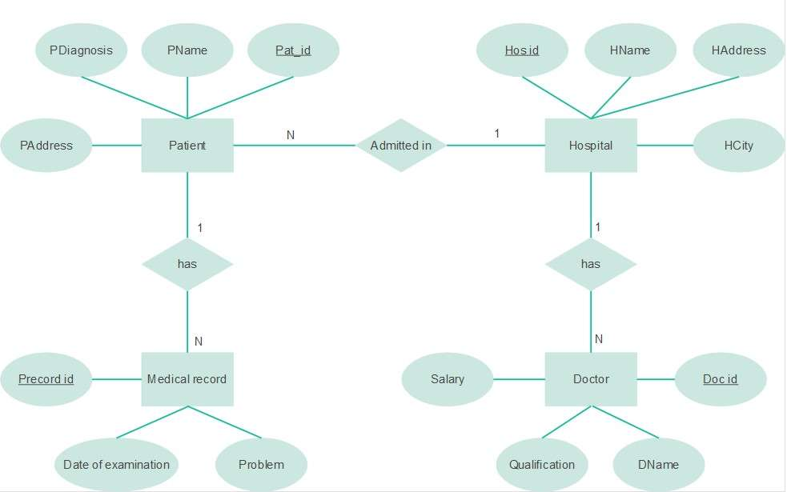
b) Write SQL query for the following consider table.
Emp(emp_id, dept, emp_name, salary, designation, joining_date, DOB, city)
i) List employees with having alphabate ‘A’ as second letter in their name.
ii) Set salary of all ‘project leaders’ to 50,000.
iii) Display average salary of all employees.
iv) Display employee-Id of employees who live in city ‘Pune’ or ‘Nagpur’.
v) Display employee name, salary and city from ‘HR’ department who having salary greater than 70,000.
vi) Display details of all employee who’s salary same as that of salary of ‘Shashank’.
Ans. i. SELECT * FROM Emp WHERE emp_name LIKE ‘_a%’;
ii. UPDATE Emp SET salary = 50,000 WHERE designation = ‘project leader’;
iii. SELECT AVG(salary) AS average_salary FROM Emp;
iv. SELECT emp_id FROM Emp WHERE city IN(‘Pune’, ‘Nagpur’);
v. SELECT emp_name, salary, city WHERE dept = ‘HR’ AND salary > 70,000;
vi. SELECT * FROM Emp WHERE salary = (SELECT salary FROM Emp WHERE emp_name = ‘Shashank’);
c) Consider schema of book table as Book_Master (book_id, book_name, author, no_of_copies, price)
Write down the SQL queries for the following.
i) Write a query to create table Book_Master table.
ii) Write a command to create composite index on Book_Master table.
iii) Write a command to drop above index.
iv) Display book name and author in decreasing order of price.
v) Display all books whose number of copies are greater than 50.
vi) Create synonym for relation Book_Master as Book_Information.
Ans. i. CREATE TABLE Book_Master(book_id INT PRIMARY KEY, book_name VARCHAR(50), author VARCHAR(50), no_of_copies INT, price INT);
ii. CREATE INDEX idx_book_author
ON Book_Master (book_name, author);
iii. DROP INDEX idx_book_author;
iv. SELECT book_name, author
FROM Book_Master
ORDER BY price DESC;
v. SELECT * FROM Book_Master WHERE no_of_copies > 50;
vi. CREATE SYNONYM Book_Information FOR Book_Master;
a) Write a PL/SQL program to print sum of n odd numbers using for loop.
Ans. DECALRE
i NUMBER;
n NUMBER := &enter a number;
sum NUMBER := 0;
BEGIN
FOR i IN 1..n LOOP
IF MOD (i,2) = 1 THEN
sum := sum + i;
END IF;
END LOOP;
dbms_outout.put_line(‘Sum of numbers from 1 to ’||n|| ‘is ’||sum);
END;
/
b) Write a command to create table Customer (Custo_id, Cust_name, address, Contact_no, City). And write down the queries for the following:
i) Insert one row into table.
ii) Save the data.
iii) Insert Second row into the table.
iv) Create save point S1.
v) Insert one row into the table.
Ans. CREATE TABLE Customer(cust_id INT, cust_name VARCHAR2(50),address VARCHAR2(50), contact_no INT, city VARCHAR2(50));
i. INSERT INTO Customer VALUES(1, ‘John’, ‘St. Avenue’, 9886574831, ‘Panvel’);
ii. COMMIT;
iii. INSERT INTO Customer VALUES(2, ‘Jack’, ‘Park Avenue’, 9226548148, ‘Vashi’);
iv. SAVEPOINT S1;
v. INSERT INTO Customer VALUES(3, ‘James’, ‘Garden Villa’, 9820754281, ‘Wadala’);

c) Describe database privileges. Write down the command for granting and revoking privileges on database object to users.
Ans. Database privileges are permissions granted to users or roles (groups of users) that determine their ability to access, modify, or manage objects within the database. These privileges are the core components of a database's security model, enforcing the principle of least privilege.

GRANT :
Query 1: Granting SELECT on a table This allows the user to read the data in the Employees table.
GRANT SELECT
ON Employees
TO analytics_user;
Query 2: Granting DML privileges with Grant Option This allows the hr_manager to insert, update, and delete records, AND allows them to pass these same privileges to other users (WITH GRANT OPTION).
GRANT INSERT, UPDATE, DELETE
ON Employees
TO hr_manager
WITH GRANT OPTION;

REVOKE :
Query 1: Revoking DML privileges This immediately removes the manager's ability to modify the table data.
REVOKE INSERT, UPDATE, DELETE
ON Employees
FROM hr_manager;
Query 2: Revoking the ability to grant permissions This removes the WITH GRANT OPTION privilege granted in the previous step.
REVOKE INSERT
ON Employees
FROM hr_manager;

